Digital Communication

**Lab Assignment: 8**

**Name: Vinit Mehta**

**Student ID: 202101477**

**Lab Group: 6**

**Experiment 1:**

**Exercise: 7:**

Input Data Type: 8-bit Input data type: 8-bit

Data clock Freq: 2KHz Data clock Freq: 2KHz  
CH1: Input Data (TP10) CH1: Input Data (TP10)

CH2: Carrier Signal (TP11) CH2: BPSK out (TP12)

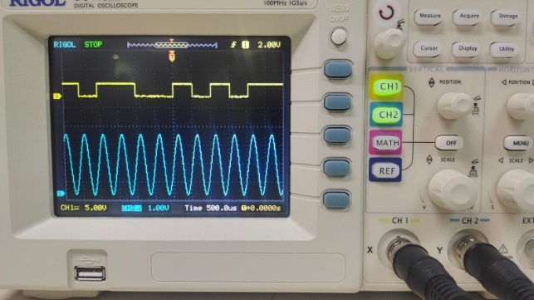 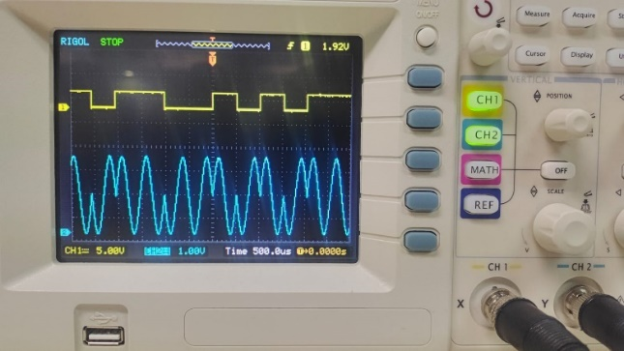

Input Data Type: 32-bit Input data type: 32-bit

Data clock Freq: 4KHz Data clock Freq: 4KHz  
CH1: Carrier Signal (TP11) CH1: Input Data (TP10)

CH2: BPSK out (TP12) CH2: BPSK out (TP12)

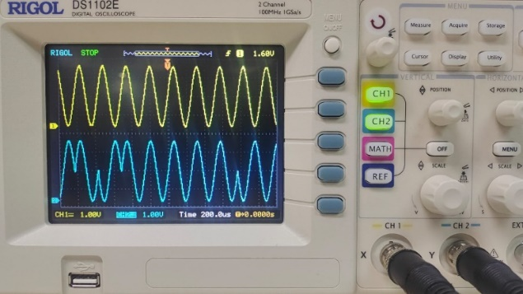 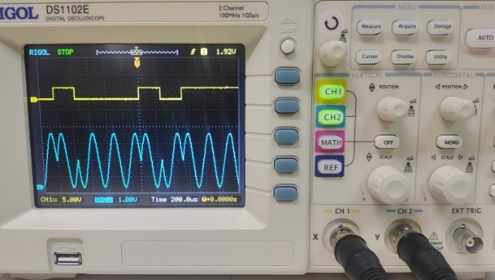

**Exercise: 8:**

Input Data Type: 32-bit Input data type: 8-bit

Data clock Freq: 4KHz Data clock Freq: 2KHz  
CH1: BPSK out (TP12) CH1: BPSK out (TP12)

CH2: Multiplier out (TP14) CH2: Multiplier out (TP14)

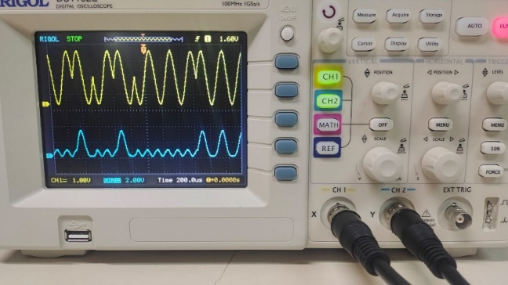 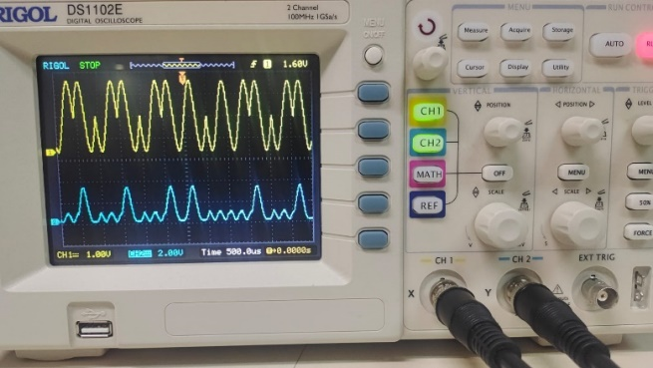

**Exercise: 9:**

Input Data Type: 32-bit

Data clock Freq: 2KHz

CH1: BPSK (TP12)

CH2:Integrator out (TP15)

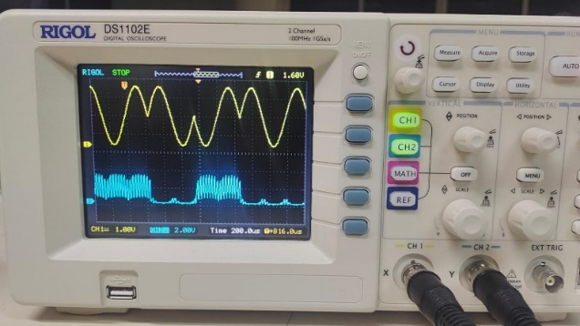

**Exercise: 10:**

Input Data Type: 32-bit Input data type: 8-bit

Data clock Freq: 2KHz Data clock Freq: 2KHz  
CH1: BPSK out (TP12) CH1: Encoded input Data (TP10)

CH2: Comparator Out (TP16) CH2: Comparator out (TP16)

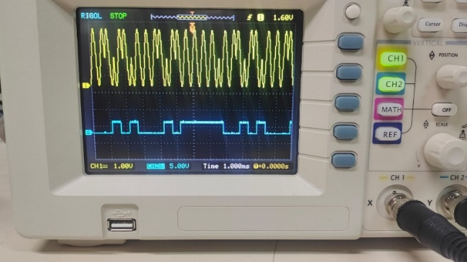 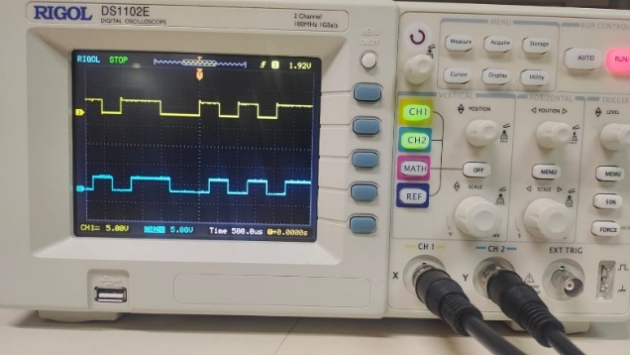

**Exercise: 11:**

Input Data Type: 8-bit

Data clock Freq: 2KHz

CH1: BPSK out (TP12)

CH2: Integrator Out (TP15)

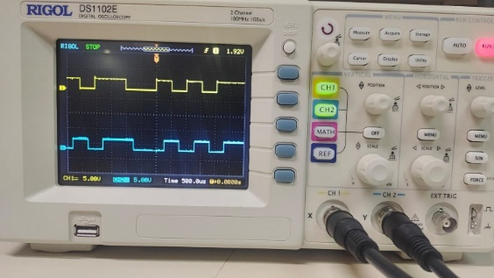

**Experiment 2:**

**Exercise: 19:**

Input Data Type: 8-bit Input data type: 8-bit

Data clock Freq: 2KHz Data clock Freq: 2KHz  
CH1: Input Data (TP2) CH1: Carrier Signal F1 (TP30)

CH2: Encoded Input Data (TP28) CH2: Carrier Signal F2 (TP29)

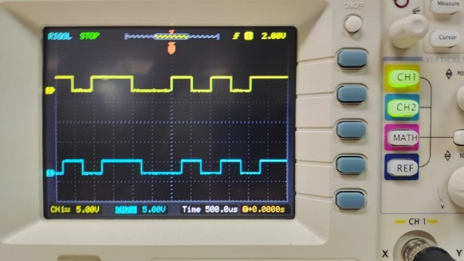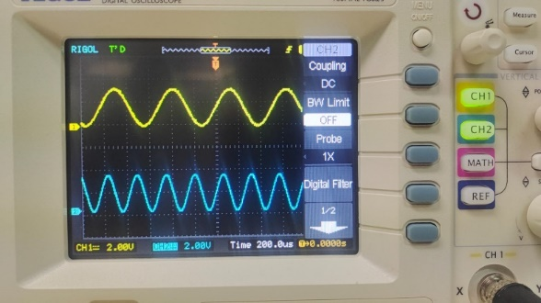

Input Data Type: 8-bit

Data clock Freq: 2KHz

CH1: Encoded Input Data (TP28)

CH2: FSK Output (TP28)

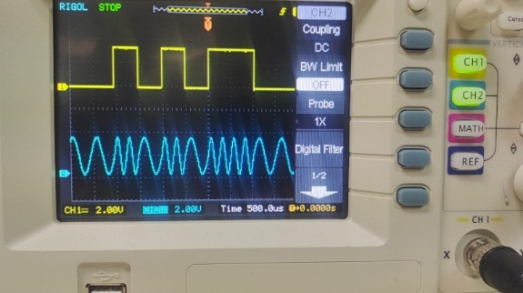

**Exercise: 20:**

Input Data Type: 8-bit Input data type: 8-bit

Data clock Freq: 8KHz Data clock Freq: 8KHz  
CH1: FSK output (TP31) CH1: FSH output (TP31)

CH2:Multiplier Out (TP34) CH2: Multiplier out (TP35)

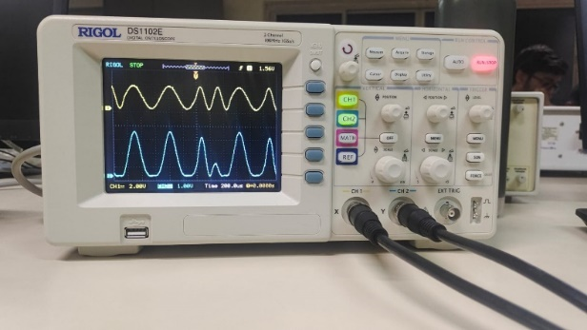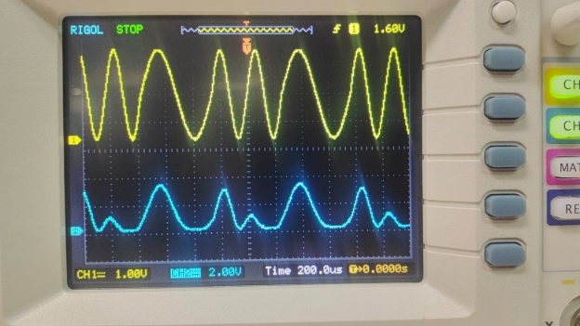

**Exercise: 21:**

Input Data Type: 8-bit Input data type: 8-bit

Data clock Freq: 8KHz Data clock Freq: 2KHz  
CH1: FSK output (TP31) CH1: FSK Output (TP31)

CH2: Integrator Out (TP36) CH2: Integrator out (TP37)

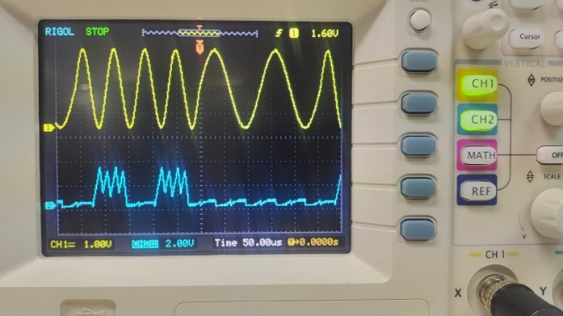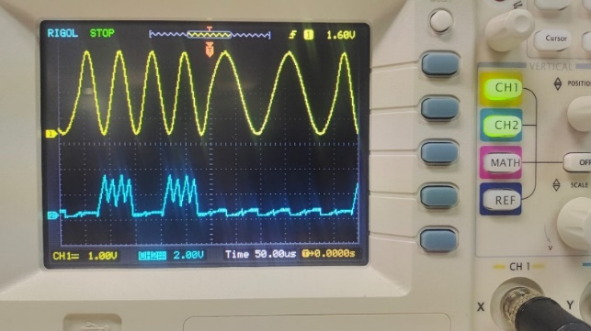

**Exercise: 22:**

Input Data Type: 8-bit Input data type: 8-bit

Data clock Freq: 2KHz Data clock Freq: 8KHz  
CH1: FSK Output (TP31) CH1: Input Data (TP28)

CH2: Sigma Out (TP38) CH2: Comparator out (TP39)

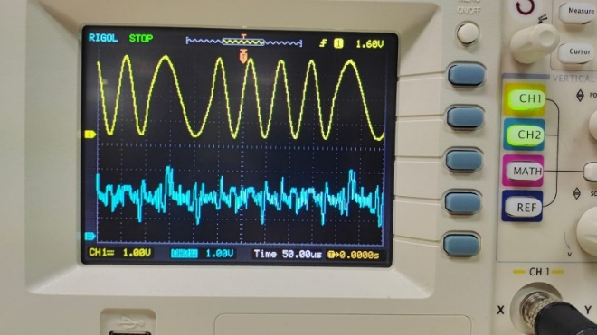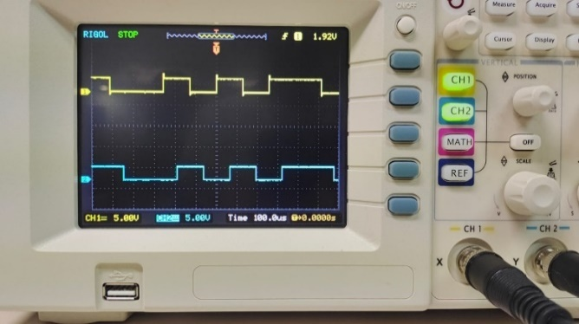

**Exercise: 23:**

Input Data Type: 8-bit Input data type: 8-bit

Data clock Freq: 2KHz Data clock Freq: 8KHz  
CH1: Input Data (TP28) CH1: Input Data (TP28)

CH2: Demodulator out (TP39) CH2: Demodulator out (TP39)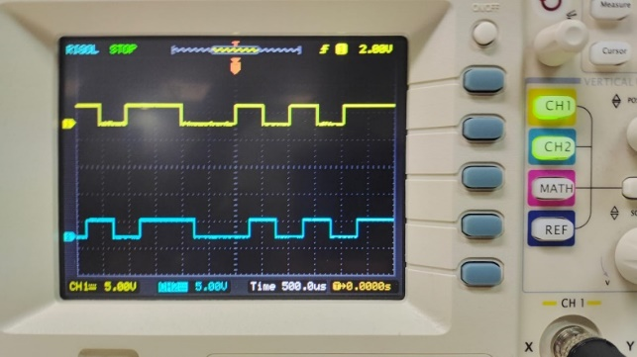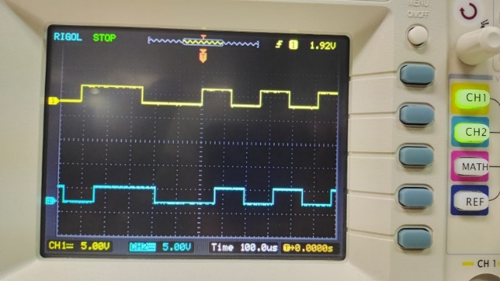

**Experiment: 3:**

% (a) Generate a vector of random variables

n = 10^6;

x = rand(1, n);

% (b) Calculate the sequence y by averaging every 100 consecutive elements of x

m = 100;

y = mean(reshape(x, m, []));

% (c) Plot the histogram of the sequence y

bins = 50;

hist(y, bins);

title('Histogram of y');

xlabel('Value of y');

ylabel('Frequency');

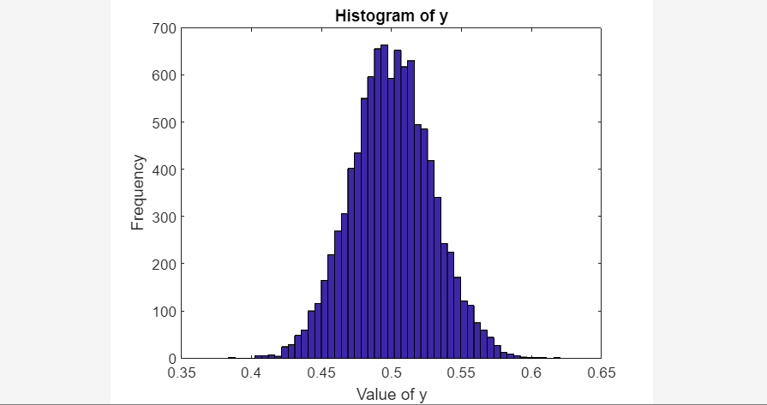

We can see that the histogram is almost like a bell-shaped curve which roughly follows a Gaussian distribution. Thus, it follows from the central limit theorem.